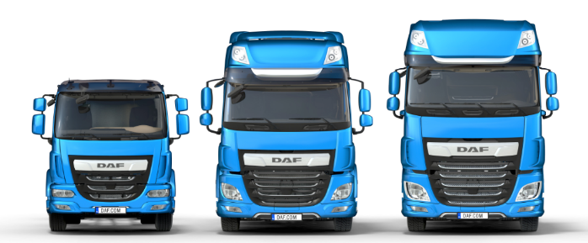
Application Form for an
Apprenticeship

PRIVATE AND CONFIDENTIAL
PLEASE COMPLETE IN BLOCK CAPITALS

Apprenticeship Applied For:

PERSONAL DETAILS

Surname Forename
Address Home Phone
Mobile
Email

Do you require a work permit to work in the UK? Yes No

It is unlawful to employ a person who does not have permission to work in the UK. Leyland Trucks will not be able to employ you if you cannot produce appropriate documentation when requested.

Why have you applied for an Apprenticeship with Leyland Trucks?

(You may like to include in your answer why you are interested in this specific apprenticeship; details of any practical projects or experiences you have; and any ideas for your future career.)

EDUCATION AND QUALIFICATIONS
School | From | To | Qualifications Obtained/Predicted (subject and grade e.g. GCSE)

College | From | To | Qualifications Obtained/Predicted (subject and grade e.g. A-Level / Degree)

Please give details of positions of responsibility held (Schools or Clubs)

WORK EXPERIENCE

Please complete the following section in date order beginning with your current or most recent employment.

Name & Address of Employer | From | To | Position Held and Duties Performed

SUPPORTING INFORMATION
Please give details of interests, hobbies and pastimes relevant to this role. (You could describe a time where you were determined to succeed):

Please detail the qualities you feel you possess that make you an ideal candidate for an apprenticeship at
Leyland Trucks:

Please describe what you anticipate to be the most beneficial aspects of undertaking this specific apprenticeship:

Please use this section to support your application by describing any particular skills, knowledge and experience you have gained and how they will assist you in your apprenticeship.

Any offer of employment is subject to us receiving two references which we deem satisfactory. You may give both references from your school / college, or one from school and one from an employer. Please give names, telephone numbers, email addresses and occupations of the two referees.
REFERENCES

Name:
Position:
Address:

Phone:
Email:

Name:
Position:
Address:

Phone:
Email:

CONDITIONS OF APPLICATION AND EMPLOYMENT

When you complete this form, you accept that employment with Leyland Trucks is subject to the following conditions:

• Satisfactory references will be required (see above)

• Passport or identification documents must be produced in compliance with
Home Office Legislation.

• An employment medical must be passed.

• Evidence of any relevant qualifications must be produced.

Declaration:
I certify that the information given on this application form including the Equal Opportunities Monitoring Form is correct. I understand that any willful omission or falsification may lead to the disqualification of this application or dismissal if
appointed.

Signed Date

RETURN COMPLETED FORMS TO:

Apprentice Recruitment  Leyland Trucks Ltd  Croston Road, Leyland, Lancashire  PR26 6LZ | Or | Leyland.Jobs@PACCAR.com

HOW WE STORE AND USE YOUR DATA

All or parts of the information on this form may be stored on computer files and used for the purpose of personnel administration, your future employment within the Company if successful, statistical and business analysis. If you are not successful for a position with the Company, your data will be stored for a period of 2 years after which it will be destroyed Such use will be subject to the provision of the Data Protection Act 2018 and relevant subsequent legislation.
Please complete this form in order to help us monitor Equal Opportunities in Employment. This form will be kept separate from your application form, and has no part in the selection process.
EQUAL OPPORTUNITIES MONITORING FORM

Surname Forename(s) Position Applied For
Gender Monitoring
Please tick appropriate box Male Female

Age Monitoring

Date of Birth

National

/ / Insurance No.

Ethnicity Monitoring
Please check the box which best describes your ethnic / cultural / racial origin:
WHITE MIXED ASIAN BLACK CHINESE British White & Black Caribbean Indian Caribbean Chinese English White & Black African Pakistani African
Scottish White & Asian Bangladeshi Other
Welsh Other Other
Irish
Other

DISABILITY MONITORING
Do you suffer with a disability as defined by the DDA, or a long term health condition?
Yes □ No □

What is the effect or impact of your disability or health condition?

Are there any reasonable adjustments that would need to be made?

Have you ever been convicted of a criminal offence (spent convictions do not need to be declared) under the
Rehabilitation of Offenders Act 1974?

(if yes please give information)
Yes □ No □

